Your expert partner
As a professional stage equipment manufacturer with 14 years of experience, Boruida has proven capability and expertise to serve customers in a variety ways.
你的专业合作伙伴
作为一家拥有14年的丰富经验的专业的舞台设备制造商，博瑞达已经向许多客户提供了服务并证明了自己的能力和专业知识。

Initial Consultation初步咨询

Manufacturing and testing制造和测试

Initia
Product design and development产品的设计与开发
On-going support持续的支持

Building close working partnerships with our customers and offering immediate after-sales service is our tenet, and we are committed to delivering solutions with flexibility, speed, precision and quality.
与客户建立紧密的合作关系，提供即时的售后服务是我们的宗旨，我们致力于以灵活、快捷、精确和优质的方式提供解决方案。

Enabling solutions for stage and studio
We provide outstandingly engineered solutions for many applications and requirements, both above and below the stage. These typically include:
- Theater Winches
- Motorized Stage Curtain
- Revolving and Lifting Platforms
- Rotating Lighting Truss

舞台和演播室的解决方案
我们为台上台下的各种应用和需求提供卓越的工程解决方案，这些通常包括：
剧院绞车
电动舞台幕布
旋转升降平台
旋转照明桁架

All of our solutions are backed up by a dedicated customer service and will deliver:
- The highest possible safety, quality and reliability.
- Design flexibility
- Silent operation
We provide complete ’plug-and-play’ systems which include motor gearboxes, brakes and mechanical or electronic limit switches and encoders.
我们所有的解决方案都支持一个专门的客户服务，并将交付：
- 尽可能高的安全、质量和可靠性。
- 设计的灵活性
- 静音操作
我们提供完整的“即插即用”系统，包括马达变速箱、制动器和机械或电子限位开关和编码器。

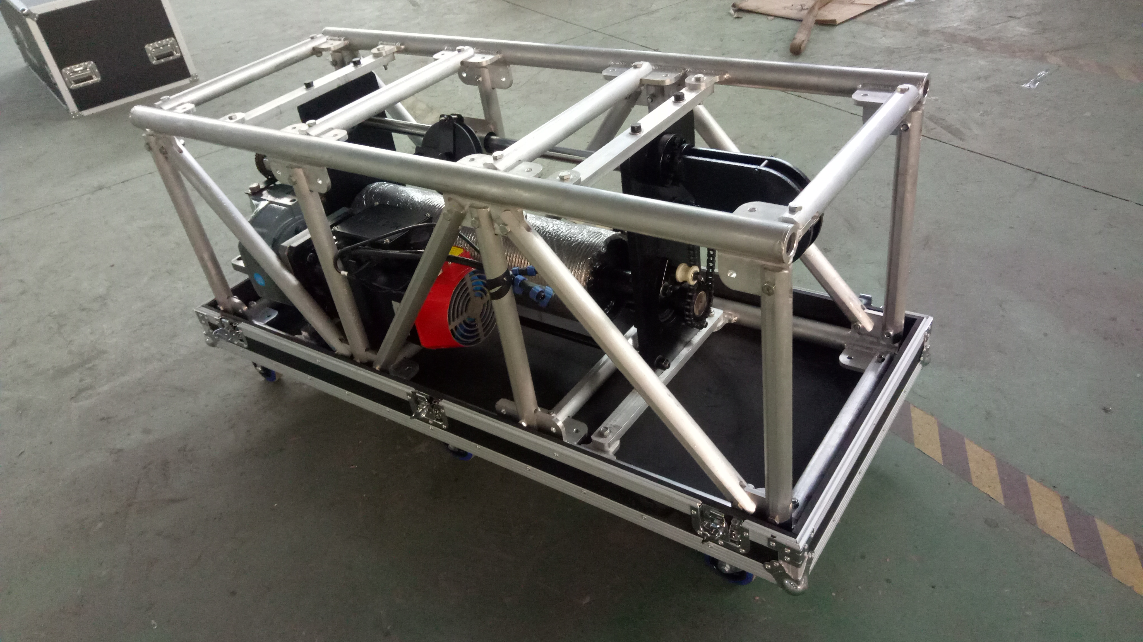
Single point winch
High performances and a very safe drive configuration are put together in a versatile winch, simple to install and, above all, suitable to deal with the most demanding event applications.
Compact zero fleet-angle design，250KG up to 2.4m/s, large travel and a very precise dynamic load measurement system are the key features of the single point winch.
It is a point hoist solution designed with high demanding event and touring application in mind.
The winch accommodates up to 40m of travel as a standard, giving also the option to keep it at stage level and have an easy and quick access to the winch in case of an emergency situation, for instance. A longer travel can be provided on request.
Standard configuration:
Dimension: 1500*600*600mm
Power: 7.5KW (servo motor)
Output speed: 259r/min
Output torque: 267Nm
Drum diameter: 200mm
Wire diameter: 7mm
Control mode: PLC + touch screen
Communication protocol: profinet
Load capacity: 250KG
Speed: 2.4m/s
Dead weight: 280KG
(customized configurations can be provided on request)

桁架单点吊机
高性能且非常安全的驱动器配置一起放在一台多功能吊机中，安装简单，最重要的是，适合处理最棘手的事件情况。
紧凑的零位移设计， 250kg可达2.4m/s，大行程和一个非常精确的动态测量系统，这些是桁架单点吊机的主要特点。
桁架单点吊机是一台为严苛情况和循环使用设计的单点吊机。
吊机可支持多达40米的行程作为一个标准，也提供一个紧急按钮以应对突发情况。可按要求提供较长的行程。
标准配置：
桁架尺寸：1500*600*600
电机功率：7.5KW（伺服电机）
输出转速：259r/min
输出扭矩：267Nm
卷筒直径：200mm（改成180）
钢丝绳直径：7mm
控制方式：PLC+触摸屏，通信协议：profinet
载荷：250KG
速度：2.4m/s
自重：280KG
（可根据要求提供定制配置）

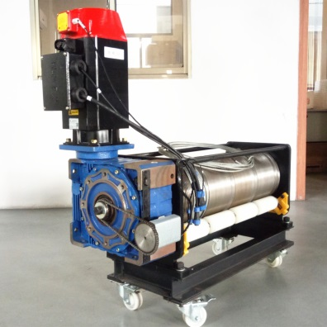
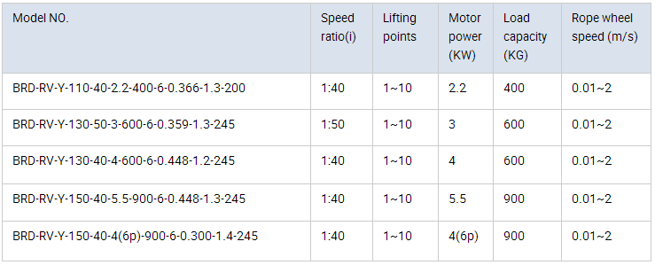

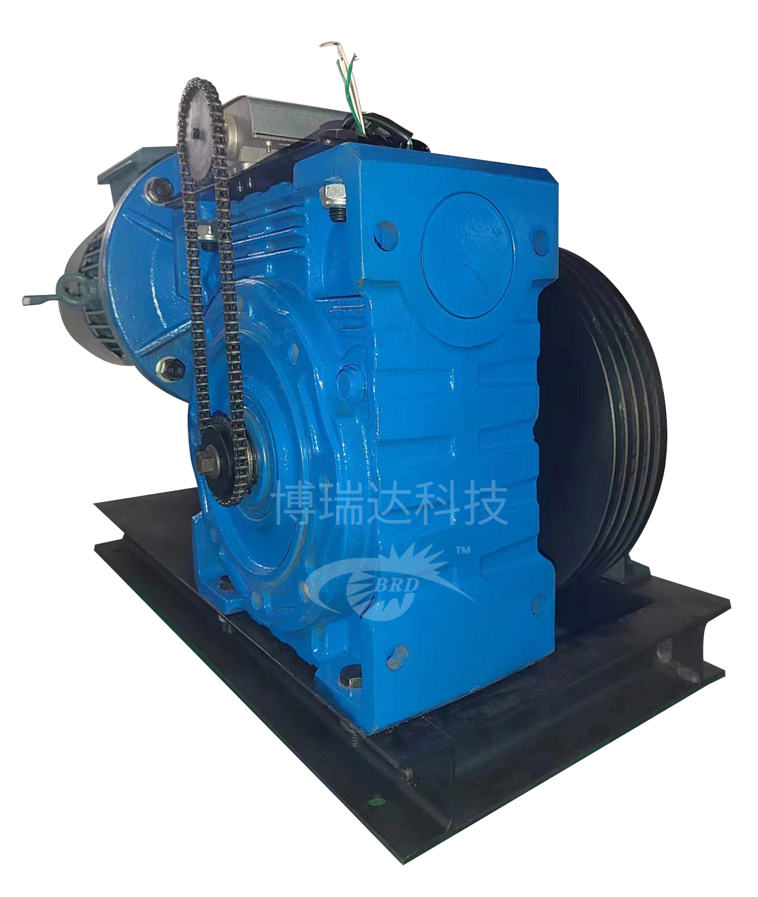

多层叠绕提升机
BRD-RV-D-110-40-2.2-600-4-0.256-1.5
电机功率：1.5-4.0（YEJ系列制动电机）
卷筒直径：起始层140mm，
钢丝绳直径：4.2 mm / 5.1mm
控制方式：手动/ PLC+触摸屏
通信协议：profinet
吊点数：2-4
载荷：200-600KG
速度：0.3m/s
自重：45-110KG

BRD-RV-D-110-40-2.2-600-4-0.256-1.5
Power: 1.5~4.0KW (YEJ series brake motor)
Drum diameter: 140mm
Wire diameter: 4.2 mm / 5.1mm
Control mode: manual/ PLC + touch screen
Communication protocol: profinet
Number of points: 2~4
Load capacity: 200 ~600KG
Speed: 0.3m/s
Dead weight: 45~ 110KG
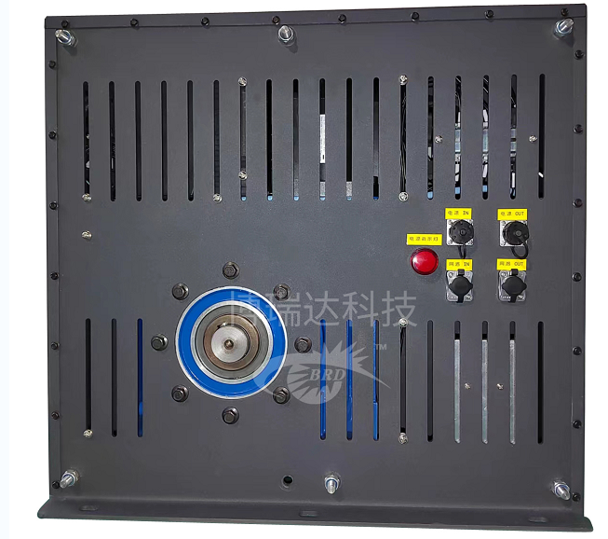

(customized configurations can be provided on request)
单点绞车
标准配置：
承载能力：250kg
速度0.15m/s
行程：8m
控制方式：伺服电机/变频/工频同步电机
钢丝绳直径：7mm，7 * 19 + NF
限制：上限、下限、耐火极限
重量：75kg
（定制的配置可以按要求提供）

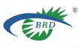Taizhou Boruida Stage Technology Co., Ltd.
Industrial Zone, Dasi Town, Gaogang District, Taizhou, Jiangsu
Tel: +86 (0)523 / 86819996
Email: brdkj@163.com
https://brdkj.en.alibaba.com

Website QR code

